Apple Core ML
1.Introduction:
Recent advancement in technology and need of different artificial intelligence, every industry is moving towards machine learning and deep learning technology. Using machine learning, Companies can train their devices to work efficiently like google is using machine learning in android that converts the speech into text and there are a lot of companies that are using these technologies. Apple introduces a machine learning framework first release in 2017 to his developers called Core ML. Using Core ML framework, a developer can introduce different machine learning capabilities (object detection, Recognition of handwritten letters etc) in IOS app with some line of code. Apple introduces a new version of this framework in 2018 Core ML 2 in San Jose. This framework can reduce the size of the model, enhance the performance and possibly will customize their own Core ML. In this paper I will discuss about object detection using apple Core ML and talk about Create ML but before diving into the topic lets create a small background about machine learning.
Machine learning:
Machine learning, it is a field of computer science which started when it was the beginning of computer science history. The first milestone for machine learning studies was set when Alan Turing asked a question “Can machines think?”. After this Arthur Samuel explained machine learning as “field of study that gives computers the ability to learn without being explicitly programmed”. And finally, the latest and accepted definition was proposed by Tom M. Mitchell: “A computer program is said to learn from experience with respect to some class of tasks and performance measure, if its performance at tasks in T, as measured by P, improves with the experience E.”
Core ML:
It is a framework through which a developer can integrate a machine learning trained model in IOS app very easily with some lines of code. Before this, it was very difficult to create an app in IOS which can learn something without explicit programming that’s why apple feels the need of machine learning trained models. In this framework, we just need a trained model with extension (.mlmodel) to integrate with our application. For this purpose, we can create our own model with sample, trained them on training data and then convert them to .mlmodel using open source services and bring them in our application. Or on the other side we can get different types of ready to use model form Apple official website, they are in .mlmodel extension we just need to integrate them in our application. For the implementation, I also get a model from official website VGG16 which perceives the main objects present in an image from a set of 1,000 categories such as trees, animals, food, vehicles, people, and more.
Creating a trained model online and then converting it into .mlmodel extension, get rid of this horrible task Apple introduces Create ML framework.
Create ML:
it helps creating trained model in the same environment in which we are developing the IOS app.
Use Create ML with aware tools like Swift and macOS playgrounds to create and train custom machine learning models on your Mac. We can train models to perform tasks like recognizing images, extracting meaning from text, or finding relationships between numerical values.

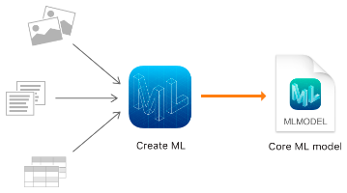
we train a model to identify patterns by showing it typical samples. For example, we can train a model to identify rabbit by showing it lots of images of different rabbits. After we have trained the model, we test it out on data it hasn’t seen before and evaluate how well it performed the task. When the model is performing well enough, we are ready to integrate it into our app using Core ML.
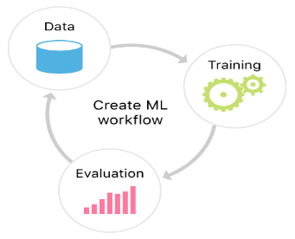
The motive of this paper is to detect different objects present in an image. The reason to detect objects is that we can make some decision on the bases of information. For example, if a customer in a store wants to buy some oranges, he/she will select the oranges in the robot and robot will automatically bring the oranges for the customer. In this paper I will discuss about the related work in core ML and Create ML then concept, implementation, result and in the last conclusion.
2.Related work:
With recent developments in machine learning based computer vision models, object detection applications are easier to develop than ever before. Also, significant performance improvements, these methods have also been leveraging huge image datasets to reduce the need for large datasets. In addition, with present methods focussing on full end-to-end pipelines, performance has also better expressively, enabling real-time use cases.
We can do object detection in Apple Core ML using different methods, hence there are advantages and disadvantages of different techniques. As we know that Apple Core ML is new in the market and is not so much intelligent, instead of using the readymade trained model or creating our own model from scratch, we can integrate IBM cloud services in IOS app, or we can use Tensor flow trained model through API’s to detect the objects in an image to get better result. In this section I will focus on IBM Watson and tensor flow in Core ML.
IBM Watson:
It is very easy to develop IOS application that can get powerful Watson capabilities exactly from iPhone or iPad, so you can deliver energetic, smart object detection applications that improve over time. And with the IBM Cloud Developer Console for Apple, you can quickly knock into Watson Services for Core ML and other services on IBM Cloud.
With IBM Cloud Developer Console, you can build IOS application that influence Watson models on iPhone and iPad, even when offline. Your app can speedily examine images, correctly classify visual content, and easily train models using Watson Services.
Let’s Get take an overview to start with pre-trained Watson models, or customize and train models that continuously learn over time.
Things you need to integrate IBM cloud service in IOS app
before getting start you must perform the following steps to bring the cloud service in you IOS app.
Go to the IBM cloud service website
Sign up for a free IBM Cloud account or log in.
Click create
Copy the credentials to authenticate ton your service instance
On the Manage page click show credentials.
Copy API Key Value
Make sure that you have the curl command.
Test whether curl is installed. Run the following command on the command line. If the output lists the curl version with SSL support, you are set for the tutorial.
$ Curl -v
Classify Images
Issue the following call to classify an image. Replace {apikey} with the service credentials you copied earlier.
“$ curl -u "apikey:{apikey}" "https://gateway.watsonplatform.net/visual-recognition/api/v3/classify?url=https://watson-developer-cloud.github.io/doc-tutorial-downloads/visual-recognition/640px-IBM_VGA_90X8941_on_PS55.jpg&version=2018-03-19"
This command is used to call the trained model of IBM Cloud Service and classify the image. In this command “640px-IBM_VGA_90X8941_on_PS55.jpg” is the image and visual recognition model is used.
The reply contains the classes identified in the image from the built-in General model ("classifier_id": "default") and a confidence score for each class. The score represents a percentage, and higher values represent higher confidences. By default, replies from the Classify calls don't include classes with a score below 0.5 (50%).
Classification with Food model
There are many models provided by IBM Cloud Service, but I used food model for example purpose.
Visual recognition has a built-in food model that can give the more accurate result about the food images.
Now let’s give a call to food model of visual recognition as same above using curl command.
“$ curl -u "apikey:{apikey}" -F "classifier_ids=food" https://gateway.watsonplatform.net/visual-recognition/api/v3/classify?url=https://watson-developer-cloud.github.io/doc-tutorial-downloads/visual-recognition/fruitbowl.jpg&version=2018-03-19
We again pass the apikey we copy earlier, and we get the reply from this api as follow:#
{
"images": [
{
"classifiers": [
{
"classifier_id": "food",
"name": "food",
"classes": [
{
"class": "apple",
"score": 0.572,
"type_hierarchy": "/fruit/accessory fruit/apple"
},
{
"class": "accessory fruit",
"score": 0.572
},
{
"class": "fruit",
"score": 0.805
},
{
"class": "banana",
"score": 0.5,
"type_hierarchy": "/fruit/banana"
}
]
}
],
"source_url": "https://watson-developer-cloud.github.io/doc-tutorial-downloads/visual-recognition/fruitbowl.jpg",
"resolved_url": "https://watson-developer-cloud.github.io/doc-tutorial-downloads/visual-recognition/fruitbowl.jpg"
}
],
"images_processed": 1,
"custom_classes": 0
}
Here we can see that classifier id is food.
Note: we must make sure that image size does not exceed then 10MB in this case.
Similarly, we can download any desired model from IBM Cloud Service and use it in our IOS app without internet.
TensorFlow:
TensorFlow is an open source python-friendly library that can classify images. it makes machine learning very fast and easier to use.
For this purpose we need TensorFlow to Core ML converter that converts the TensorFlow model into .mlmodel extension.
Dependencies
- tensorflow >= 1.5.0
- coremltools >= 0.8
- numpy >= 1.6.2
- protobuf >= 3.1.0
- six >= 1.10.0
We can download the latest version of Core ML converter from the following link.
https://github.com/tf-coreml/tf-coreml.git
After downloading this we must install this as package, for this we use the following command
Pip install -u tfcoreml
After installing this we can easily convert the TensorFlow model to Core ML mode using the following code and then integrate the .mlmode in IOS app.

import tfcoreml as tf_converter
tf_converter.convert(tf_model_path = 'my_model.pb',
mlmodel_path = 'my_model.mlmodel',
output_feature_names = ['softmax:0']
There are many limitations in using IBM Cloud Service and TensorFlow converter like for the better result from IBM Cloud Service we always need internet connection because local models of IBM Cloud Service are not so much intelligent. By using internet user privacy may disturbed and if there is no internet user cannot get the better result. Similarly, with the TensorFlow there is a cycle error, to dodge this error we must write number of lines of code that our TF graph will not go into cycle error (cycles are generally created due to control flow ops like if, while, map, etc.).
Hence in the beginning of Core ML framework, their own models were not so much intelligent but nowadays we can find very intelligent readymade model in .mlmodel extension from Apple official website. Usage of trained model provided by Apple is very simple, we just need to write 3 lines of code and it works very efficiently and correctly
Advantage of ready-made Core ML trained model
These are the following advantage of ready-made trained model from official Apple website.
- They are in ready-made form.
- No need to write any extra lines of code to used them in IOS application.
- Integrated in IOS app therefore, no need of internet.
- They run on the user machine so, there is no privacy issue.
- By running them on user machine make them very efficient.
- Core ML 2 reduces the size of trained model, customized them and make them very intelligent.
These are the reason I choose Apple Core ML ready-made trained model for object detection application in IOS.
 | IBM Watson | TensorFlow | Ready-made
Internet | Yes | No | No
Confidence/Accuracy | >80% | >70% | >80%
Speed | Slow | Slow | Fast
User Privacy | No | Yes | Yes
Extra code | Yes | Yes | No
With this there is new framework proposed by Apple in April 2018 is Create ML. Create ML is used to create our own model in XCode. The biggest advantage of this framework is that, a person who is developing IOS application have a knowledge of XCode and Swift, can easily develop their own model with some simple steps and by collecting the data and putting them in a folder.
Concept:
In this paper I am explaining about how I develop an object detection application in IOS. The concept of this application is to detect different kinds of objects in an image coming live in front of the camera. With the help of this application a person can detect many kinds of objects for example if a person doesn’t know about different kinds of flower, he/she can detect the flower with the help of application and application will tell the name of the flower. If a user brings an image or real fruit in front of the camera, the application will show the name of the fruit like banana, orange etc.
For the live object detection application in IOS, I choose VGG16 model and Core ML framework in XCode with swift. VGG16(trained model) is most famous and intelligent model for object detection in Core ML. its accuracy for detecting the objects in an image is greater than 80% and it gives very fast result.
UML diagram
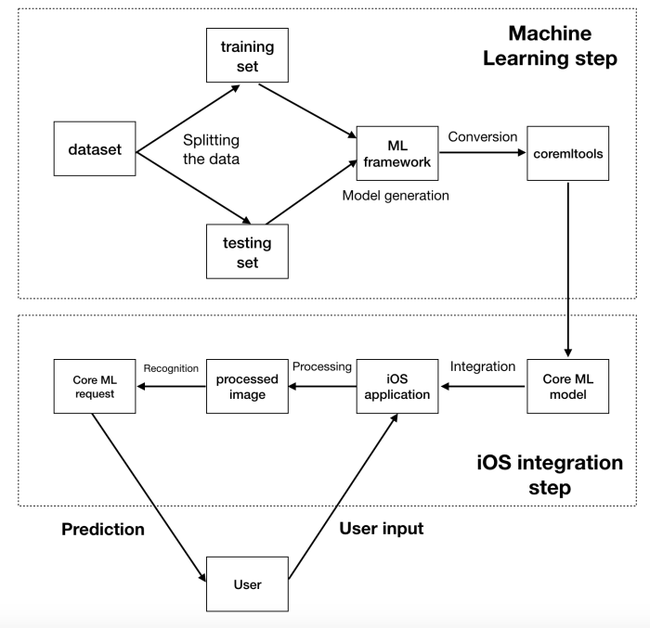

Use case
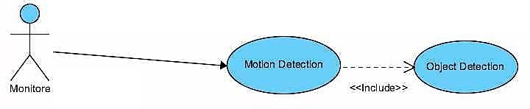
Core ML
Core ML is a framework which is used to integrate machine learning in IOS app. With the help of this framework we can integrate trained model in IOS applications very easily. The interesting thing is here that you don’t need to have the deep knowledge of machine learning and deep learning, everything is ready for you by Core ML.
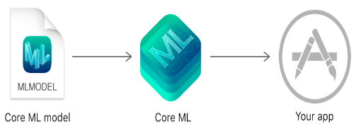
Source: https://developer.apple.com/documentation/coreml

Core ML is the basis for domain-specific frameworks and functionality. Core ML supports Vision for image examination, Natural Language for examining the processing of natural language, and evaluate the decision trees using GameplayKit. Core ML itself builds on top of low-level natives like Accelerate and BNNS, along with Metal Performance Shaders.
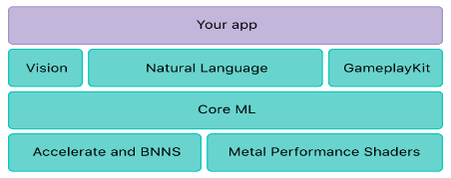
Source: https://developer.apple.com/documentation/coreml

Core ML is adjusted for on-device performance, which reduces memory footmark and power utilization. operating surely on the device guarantees the privacy of user data and guarantees that your application remnants functional and responsive when a network connection is unreachable.

Trained model
Trained model are models which we get as a result of applying different machine learning algorithms on training data. We give some test data with machine learning algorithms then we get trained model back as a result. Then the model makes forecasts based on new input data. For example, a model that's been trained on a fruit’s images may be able to predict a fruit name when we give it a new fruit image. For this object detection application in IOS we don’t need to create trained model we can use ready-made trained model as VGG16.
VGG16 model
VGG16 model is readily available on the official website of Apple. You can get it from there and just drag the model into the application. VGG16 model senses the objects from an image and has several categories like trees, animals, food, peoples, vehicles and much more.
XCode:
XCode in an Integrated development environment for developing the Apple operating system for example IOS, WatchOS, tvOS and OS X. The integrated development environment (IDE) covers a suite of software development tools, supportive source code for programming languages for example C, C++, Objective-C, Objective-C++, Java, AppleScript, Python, Ruby, ResEdit (Rez), and Swift. User of XCode can develop, build and edit applications and work with them from their early idea to finally releasing it to the Apple Store. I used XCode 10 because it is the latest version of XCode nowadays. First release of XCode was in 2003.
Feature of XCode:
- Source editor
- Asset catalog
- Open quickly
- Version editor
- Interface builder built in
- Simulator
- Live issues
Swift
swift is open source powerful, multi paradigm and intuitive language developed by Apple for macOS, iOS, watchOS and tvOS.
“Swift controlling type inference and pattern matching with a modern, lightweight syntax, allowing complex ideas to be expressed in a clear and concise manner. As a result, code is not just easier to write, but easier to read and maintain as well.”
Fast and powerful:
From the starting of the concept of swift, it was built to be fast. Using the extremely high-performance LLVM compiler, Swift code is transformed into improved native code so it will be run on the modern hardware or it will take the most modern hardware. The standard library and syntax is also adjusted to write the code for best performance.
Swift is a successor to both the C and Objective-C languages. It includes low-level primitives such as types, flow control, and operators. “It also provides object-oriented features such as classes, protocols, and generics, giving Cocoa and Cocoa Touch developers the performance and power, they demand.”
Rules and features:
- Initialized variables before using them.
- Out of bound error checks for arrays indices.
- Overflow error is being checked for integers.
- It is the duty of Optionals that nil is explicitly handled.
- Automatically memory management.
- With the help of error handling we can recover crash application from failure point.
- Its speed is very fast.

Create ml:
With the help of Create ML framework we can develop our own model and train them on sample data to make them efficient, but for this we need a lot of sample images of different categories like fruits, animals, humans, cars, buses, motor bikes, laptops, keyboard etc.
First, we need to create categories. I will explain the concept of one category ‘Animals’. We need to make a root folder animal, then sub folders with labels like dog, cat, frog etc. and finally put minimum 10 images in each folder, for example 10 images of different cats in cat folder. Similarly in others folders

References:
- https://www.theseus.fi/bitstream/handle/10024/144361/Do_Duc.pdf?sequence=1
- https://learncodeonline.in/introduction-of-apples-machine-learning-framework-core-ml/
- https://www.quora.com/What-is-the-motivation-of-object-detection
- Girshcik et al., "Faster R-CNN: Towards Real-Time Object Detection with Region Proposal Networks", NIPS, 2015.
- Zhiqiang Shen, Zhuang Liu, Jianguo Li, Yu-Gang Jiang, Yurong Chen, and Xiangyang Xue. Dsod: Learning deeply supervised object detectors from scratch. In the IEEE International Conference on Computer Vision (ICCV), volume 3, pp. 7, 2017.
- Sergey Ioffe and Christian Szegedy. Batch normalization: Accelerating deep network training by reducing internal covariate shift. In International Conference on Machine Learning, pp. 448–456, 2015.
- https://towardsdatascience.com/going-deep-into-object-detection-bed442d92b34
- https://developer.apple.com/ibm/
- https://www.infoworld.com/article/3278008/tensorflow/what-is-tensorflow-the-machine-learning-library-explained.html
- Y. Bengio, A. Courville, P. Vincent, "Representation Learning: A Review and New Perspectives", IEEE Transactions on Pattern Analysis and Machine Intelligence, vol. 35, no. 8, pp. 1798-1828, 2013.

